EduPredict Project Documentation

Cover Page

1. Institute Name
APTECH Institute

2. Project Title
EduPredict: Leveraging Big Data Analytics to Predict Student Dropout (6th Semester Project)

3. Submitted By:
Mubashir
Aleena
Warad
Ayesha

4. Submitted To:
Teacher’s Name: Sir Aun

5. Date:



Table of Contents

1. Introduction
2. Objectives of EduPredict
3. Problem Statement
4. Project Tasks and Goals
5. Functional Requirements
6. Machine Learning Models
7. Application Architecture
8. Application Demo
9. Challenges and Solutions
10. Future Work

Detailed Sections

1. Introduction
Context : This section emphasizes the growing importance of data driven decision making in education. It highlights the critical challenges faced by educational institutions, such as high dropout rates and the need for personalized learning experiences to better retain students.
Project Overview : EduPredict is introduced as a solution to predict student dropout rates using big data analytics. The project aims to improve student retention and help educational institutions optimize their resources through early intervention and targeted support.

2. Objectives of EduPredict
Primary Objective : Develop a predictive model to identify students at risk of dropping out, enabling educators to make timely interventions.
Secondary Objectives : Equip students with hands on experience in handling real world data projects, bridging the gap between theoretical knowledge and practical application within data science.

3. Problem Statement
Challenges in Education : High dropout rates lead to wasted resources and unfulfilled educational objectives. Institutions often struggle to identify at risk students early enough to intervene effectively.
Proposed Solution : By analyzing student data, EduPredict leverages big data analytics to forecast dropout likelihood. This predictive tool provides actionable insights for educators, helping them focus on at risk students and improving overall institutional outcomes.

4. Project Tasks and Goals
Data Collection : Diverse datasets were gathered, including academic records, attendance logs, and demographic data, to create a comprehensive student profile for analysis.
Model Development : Machine learning models were designed and trained to predict student dropout. Various algorithms were evaluated to find the optimal approach.
Application Development : A user friendly web application was developed to allow stakeholders, such as educators and administrators, to access predictions and insights easily.

5. Functional Requirements

Data Ingestion : EduPredict supports data input in multiple formats and enables real time updates to keep the information current.
Data Processing : The system is designed to efficiently handle large datasets, including capabilities for data cleaning and transformation.
Predictive Analytics : The application provides accurate dropout predictions, highlighting the factors influencing each prediction.

6. Machine Learning Models
Model Selection : Algorithms such as Random Forest, Support Vector Machines, and Neural Networks were assessed to determine the most suitable model for dropout prediction.
Feature Engineering : Key features that influence dropout rates were identified, including academic performance, engagement metrics, attendance records, and demographic data.
Model Evaluation : The model’s performance was evaluated using metrics like accuracy, precision, recall, and AUC ROC to ensure reliable predictions.

7. Application Architecture
Frontend : The application interface was developed using Streamlit, providing an interactive experience for users.
Backend : Python was used to process data and integrate the predictive model.
Data Storage : Databases were implemented to store user inputs and prediction results securely, ensuring privacy and easy access.

8. Application Demo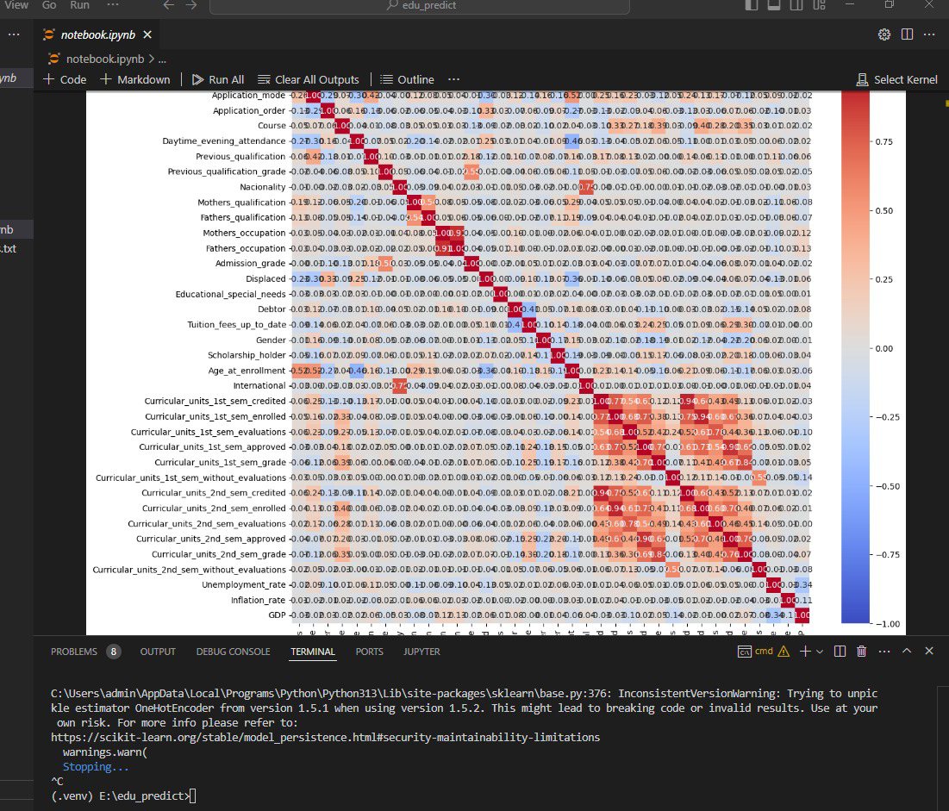
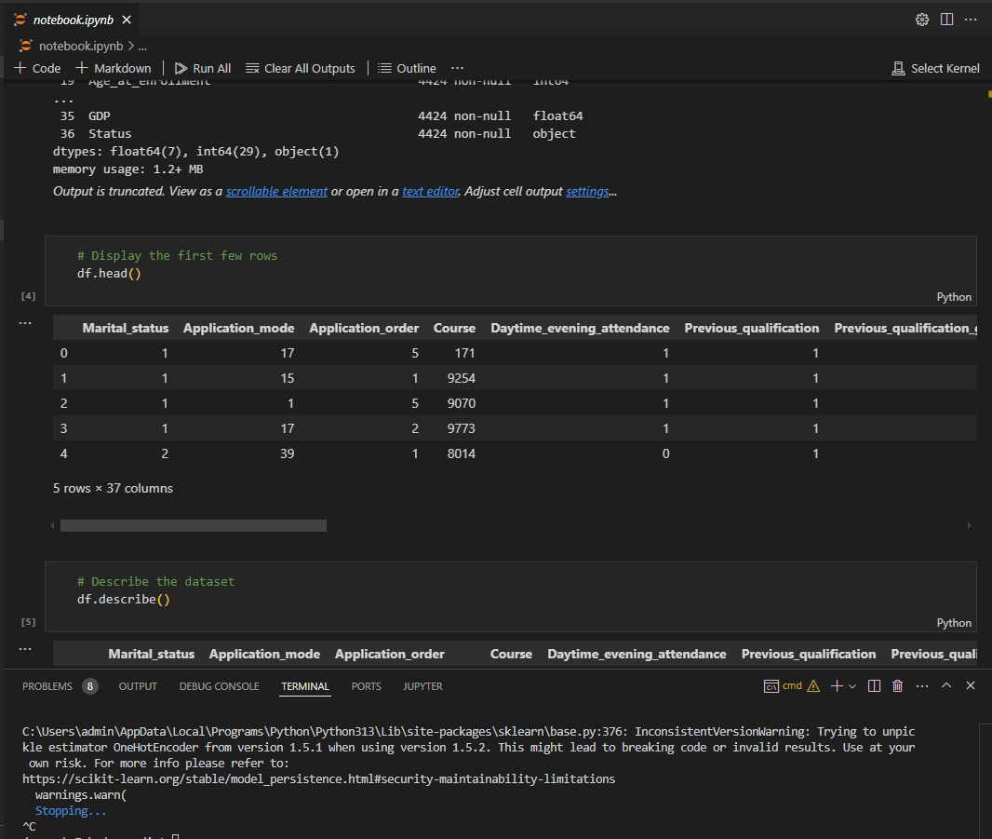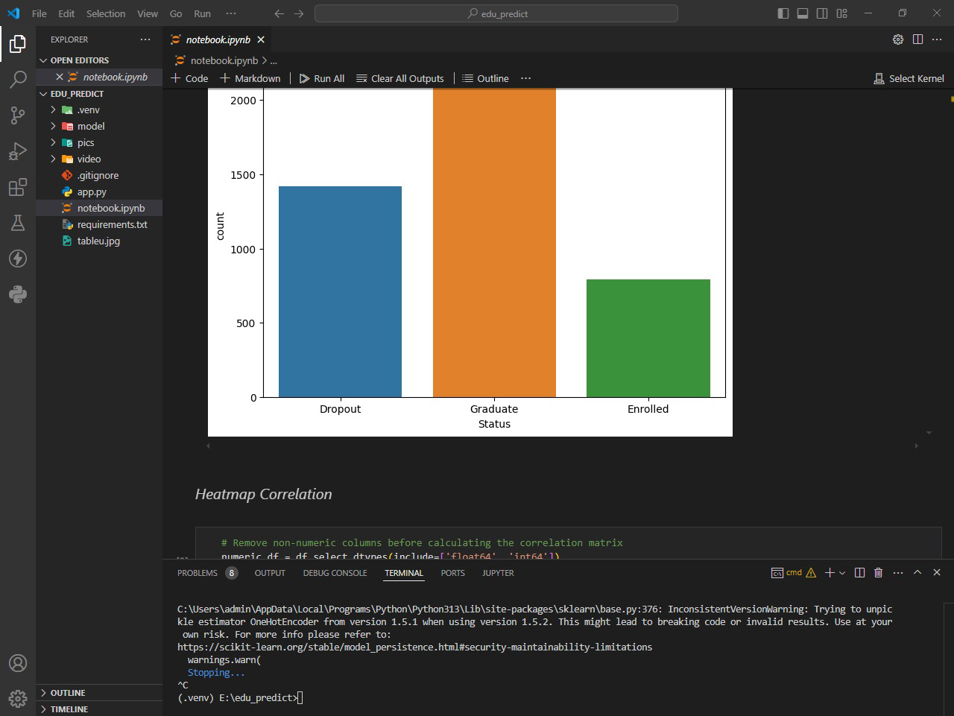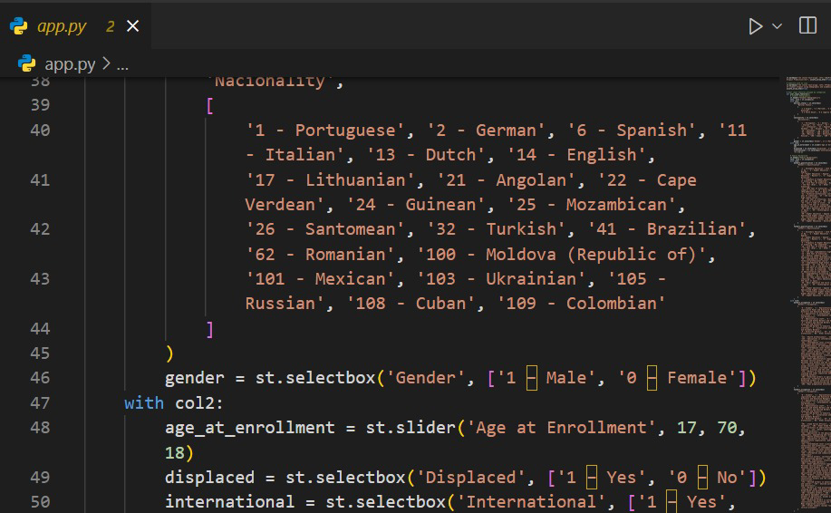
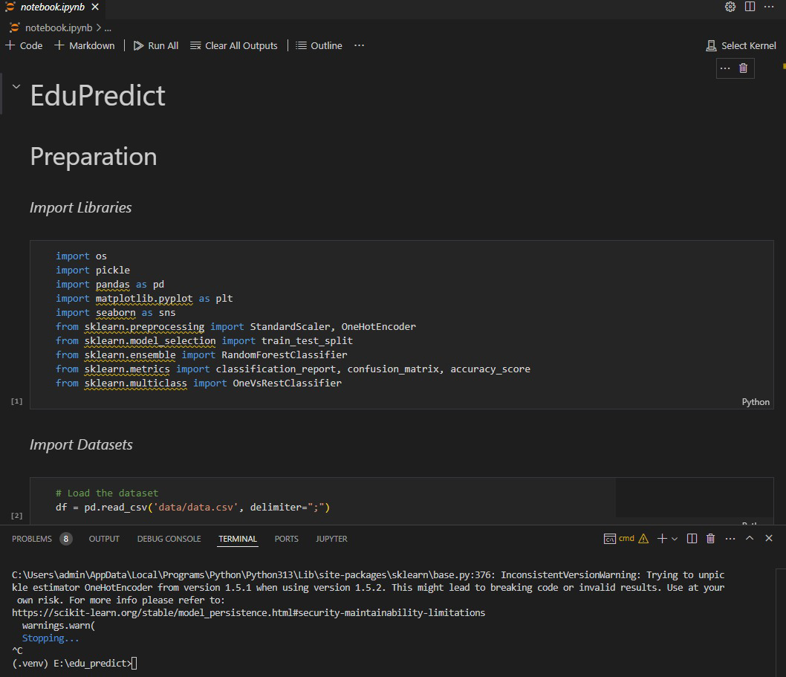

9. Challenges and Solutions
Data Quality : Addressed challenges related to missing or inconsistent data, which can impact model performance.
Model Interpretability : Ensured that the predictions were transparent and understandable to non technical stakeholders.
Scalability: Designed the application to handle larger volumes of data and users as the system expands, maintaining performance and accuracy.

10. Future Work
Model Enhancement: Additional data sources could be incorporated to further improve prediction accuracy.
Feature Expansion: Future versions may include features for personalized recommendations and interventions, enabling even more targeted support.
Deployment: Plans for deploying EduPredict in educational institutions to gather feedback and refine the system based on real world usage.



